Experiment 12: Design Turing Machine (TM) Using Simulator to Accept the Language
Aim
To design and simulate a Turing Machine (TM) that accepts the language
where the number of a's is equal to the number of b's.

Algorithm
- Start from the leftmost symbol of the input string.
- Replace the first unmarked a with X.
- Move right to find the first unmarked b and replace it with Y.
- Return to the beginning of the tape.
- Repeat Steps 2–4 until all a's are marked.
- Check whether any unmarked b remains.
- If all a's and b's are marked, accept the string.
- Otherwise, reject the string.

Procedure
- Open the Turing Machine simulator (e.g., JFLAP).
- Create the required states.
- Mark the initial state as the start state.
- Add transitions to replace each a with X and move right.
- Add transitions to replace the corresponding b with Y.
- Move the tape head back to the beginning after marking each pair.
- Repeat the process until all symbols are marked.
- Accept the string if only X, Y, and blank symbols remain on the tape.
- Test the machine with different input strings.

Input
ab
aabb
aaabbb

Output
Input : ab → Accepted
Input : aabb → Accepted
Input : aaabbb → Accepted
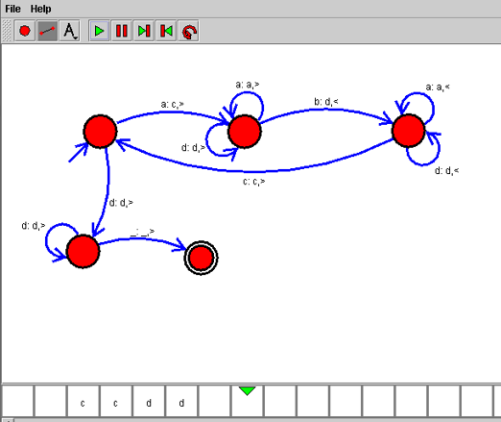

Result
Thus, the Turing Machine (TM) was successfully designed and simulated to accept the language L = { aⁿbⁿ | n ≥ 1 }. The machine correctly accepted strings containing an equal number of a's followed by b's and rejected all invalid strings.

